<<COURT_NAME>>

|  |  |
| --- | --- |
| <<PROVIDER_SUITNAME>>,  a/a/o <<INJUREDPARTY_NAME>>  Plaintiff,  vs.  <<INSURANCECOMPANY_SUITNAME>>  Defendant  _______________________________________/ | Case No. <<INDEXORAAA_NUMBER>> |

**MOTION TO INVOKE THE RULES OF CIVIL PROCEDURE**

**AND TO WAIVE PARTIES’ APPEARANCE AT THE PRE-TRIAL CONFERENCE**

Plaintiff, <<PROVIDER_SUITNAME>>, by and through the undersigned counsel, pursuant to 7.020, *Fla. Sm. Cl. R.*, hereby requests that this honorable Court waive the undersigned’s personal appearance at the initial pre-trial conference, scheduled for <<PTC_DATE>>, and to invoke the Florida Rules of Civil Procedure.

**CERTIFICATE OF SERVICE**

I HEREBY CERTIFY that on February 19, 2022, a true and correct copy of the foregoing was filed and served on the Defendant through Florida Courts E-Filing Portal.

**Florida Insurance Law Group, LLC**

8724 Sunset Drive, #260, Miami, FL 33173

Tel. (305) 906-4262

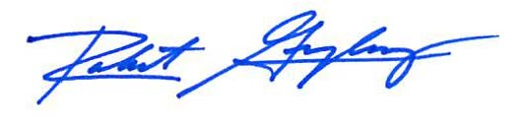

Robert F. Gonzalez, Esq.

Fla. Bar No. 68865

Pleadings@flinslaw.com